## DevOps Answers

1.

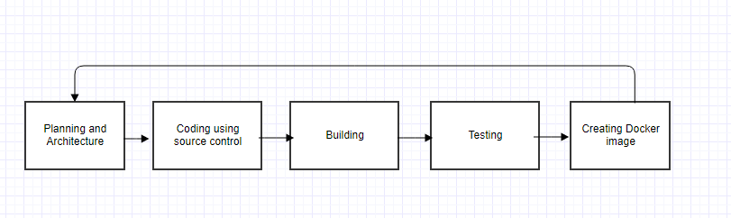

**Planning and Architecture:**

Plan and describe the system, its objectives and goals and its general architecture.

**Coding:**

Create a source control github account for the project.

Code using the Agile method with emphasis on peer programming and TDD for code quality.

**Building:**

When satisfied with the code result build the product that will later be used to deploy the application.

Creating a setup.py file to make an easier deploy, follow structure (<http://docs.python-guide.org/en/latest/writing/structure/>).

**Testing:**

Test the code for many cases to make sure of the standards and quality.

**Creating Docker Image:**

create the docker image and install the software on it.

2. Agile tries to solve communication issues between developers, QA, and DevOps.

It helps the team be aware of the issues in development and bring the product faster to market.

3. DevOps solve the problems of providing the technical infrastructure to the operations team, allowing quick and easy accesses to the operations system and automating time consuming tasks so production will go more efficient and faster.